## Experiment 2 Channel Capacity

## Purpose:

1. Understanding the properties of average mutual information.
2. Understanding the capacity of DMC.

## Principle:

The following formulas may be useful during the experiment.

* 1. Average mutual information



* 1. Capacity of general DMC

Constraint:



* 1. Conditional entropy



## Procedure:

1. **Channel Capacity with 2 inputs**

Let the channel transition probability matrix . We now evaluate the channel capacity and optimum input distribution by an one-dimensional **exhaustive search** (穷搜法) given as follows:

1. Evaluate the average mutual information based on **equation 2.1** for a given input distribution.
2. To obtain the optimum input distribution, searchfrom **0.001 to 0.999** with an interval of **0.001**.
3. Record the optimum input distribution and the channel capacity.
4. Draw a 2-D picture of the average mutual information against the input probability.

Hint: One can verify your result for the average mutual information 0.191165 of a special input distribution .

1. **Channel Capacity with 3 inputs**

Let the channel transition probability matrix . We now evaluate the channel capacity and optimum input distribution by a two-dimensional **exhaustive search** given as follows:

1. Evaluate the average mutual information based on **equation 2.1** for a given input distribution.
2. To obtain the optimum input distribution, searchfrom **0.001 to 0.999** with an interval of **0.001**, and.
3. Record the optimum input distribution and the channel capacity.
4. Draw a 3-D picture of the average mutual information against the input probability.
5. **Channel Capacity with 5 inputs**

Let the channel transition probability matrix  be a  matrix in the file “data3.3”. **Discuss in the report that is it efficient to compute the channel capacity based on the exhaustive search?** We then evaluate the channel capacity and optimum input distribution by the iterative algorithm given as follows:

1. Let the initial input distribution  be the **uniform distribution**. The initial values of  and  are 0 and 1 respectively.
2. During each iteration, evaluate the average mutual information **for each input symbol**, where *s* and *K* denote the length of output and input, respectively.
3. Update, and .
4. Loop steps 2-3 until .
5. Output the channel capacity , and the optimum input distribution .

The flowchart is shown as follows:

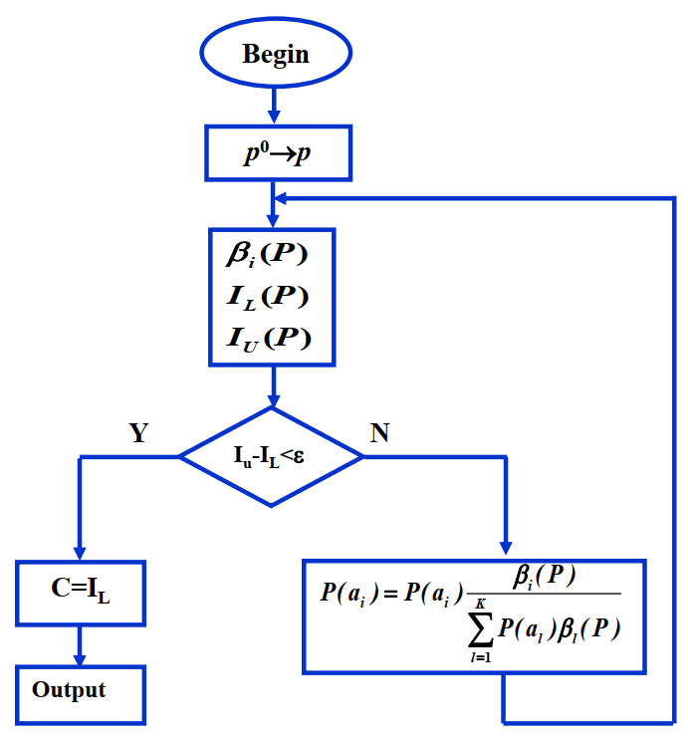

Record the channel capacity and optimum input distribution from the iterative algorithm.

1. **Channel Capacity with 100 inputs**

Let the channel transition probability matrix  be a  matrix in the file “data3.4”. **Discuss in the report that can you still use the exhaustive search-based method to compute the channel capacity and optimum input distribution?** We now use the iterative algorithm given in 3.3 to compute the channel capacity, record the results and record how many iterations are needed for calculation.

1. **Channel Capacity for special channels (optional)**

Let the channel transition probability matrix  be a  matrix in the file “data3.5”. We first evaluate the channel capacity and optimum input distribution by the iterative algorithm shown in 3.3. Record the channel capacity and optimum input distribution.

We then calculate the channel capacity by a linear equation-based method given as follows:

1. Check if such that the transition probability matrix is nonsingular (by using det() function)
2. Let  be the unknowns of the linear equations.
3. Formulate the linear equations by



Note that the above linear equations can be formulated by , where *A* is a  vector, *Q* is the  channel transition probability matrix, and *b* is the  unknown vector. The unknowns can thus be solved by . (using inv() in Matlab for matrix inversion )

1. We have  from the linear equations of step 3, and C is given by .
2. Calculate the optimum output distribution from .
3. Next, we can calculate the optimum input distribution by solving . The above linear equations can be formulated by , where *B* is a  vector for the output distribution, *Q* is the  channel transition probability matrix, and *p* is the  unknown vector for the input distribution. The optimum input distribution can be solved by .

Record the channel capacity and optimum input distribution calculated by the iterative algorithm and the linear equation-based algorithm.

## Report Requirements:

1. Answer the questions given in the above procedure.
2. Discuss the advantages and disadvantages of the exhaustive search-based, iterative, and linear equation-based algorithms.